Blue Moon Astrology Directions

1730 SW Harbor Way #308 Portland 503.242.1214
Maps on page 1

Written directions on page 2 and 3.

Downtown Vicinity Map

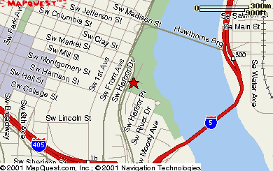

RiverPlace Detail Map
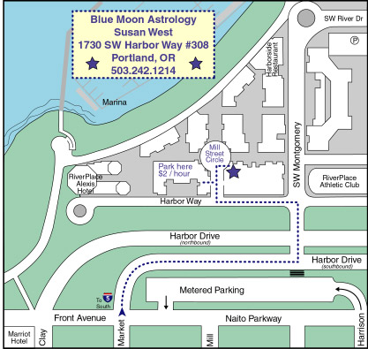

Directions to Blue Moon Astrology
See parking information at bottom of written directions.

Streetcar Directions
Exit RiverPlace at Moody.
Walk one block North on River Dr. toward the Esplanade.
Left on Montgomery.
Right on Harbor Way.
Right on Mill Street Circle. (Note: My lobby is hidden on Google Maps and Mapquest)
First lobby on the right. Pick up phone.
Dial 016 Blue Moon Astrology.

I-84 West Bound (from Gresham)
Stay in the center lane, Exit I-5 South
Take the next exit, City Center/OMSI
Move to the right lane and take Morrison Street
Exit right lane on bridge take exit to Front Avenue
Follow Front Avenue to Market Street, I-5 South sign
Turn left onto Market Street, go to far left turn lane
At stop light turn left onto Montgomery to RiverPlace Marina
Take immediate LEFT on Harbor Way.
Then first RIGHT onto Mill Street Circle (driveway between buildings)
Walk across to circle--Susan’s door first bldg. on RIGHT (yellow and white bldg./reddish door trim). Note: My lobby is hidden on Google Maps and Mapquest.
Pick up phone. Dial 016 Blue Moon Astrology.
.

I-5 South Bound (from Washington)
Take the Oregon City/OMSI Exit
Stay right follow the sign for Morrison Street
In the right lane on bridge take Naito Parkway (Front Avenue) Exit
Follow signs I-5 South back under bridge on Front Avenue
Follow Front Avenue to Market Street, I-5 South sign
Turn left at Market Street, stay in far left turn lane
Turn left at stop light onto Montgomery Street
Take immediate LEFT on Harbor Way.
Then first RIGHT onto Mill Street Circle (driveway between buildings)
Walk across to circle--Susan’s door first bldg. on RIGHT (yellow and white bldg./reddish door trim). Note: My lobby is hidden on Google Maps and Mapquest.
Pick up phone. Dial 016 Blue Moon Astrology.

I-5 North Bound (from Salem)
Be in left lane of I-5 North to Exit 299b, City Center/Beaverton
Stay in the left lane to exit 1a, Naito Parkway (Front Avenue)
At second light turn right onto Montgomery Street
Take immediate LEFT on Harbor Way.
Then first RIGHT onto Mill Street Circle (driveway between buildings)
Walk across to circle--Susan’s door first bldg. on RIGHT (yellow and white bldg./reddish door trim). Note: My lobby is hidden on Google Maps and Mapquest.
Pick up phone. Dial 016 Blue Moon Astrology.
.
Hwy 26 East Bound (from the Coast)
Take the Market Street/City Center Exit center lane
Continue down Market Street, about 13 blocks toward the river
Cross over Naito Parkway (Front Avenue), staying on Market move to far left turn lane
Turn left at stop light onto Montgomery Street
Take immediate LEFT on Harbor Way.
Then first RIGHT onto Mill Street Circle (driveway between buildings)
Walk across to circle--Susan’s door first bldg. on RIGHT (yellow and white bldg./reddish door trim). Note: My lobby is hidden on Google Maps and Mapquest.
Pick up phone. Dial 016 Blue Moon Astrology.

Hawthorne Bridge (from SE):

Cross Hawthorne Bride, turn left (south) on the west side of the bridge onto 1st
Turn left at Market Street, stay in second lane to the left
Cross Naito (Front)
Turn left at stop light onto Montgomery Street
Take immediate LEFT on Harbor Way.
First RIGHT onto Mill Street Circle (driveway between buildings)
Walk across to circle--Susan’s door first bldg. on RIGHT (yellow and white bldg./reddish door trim). Note: My lobby is hidden on Google Maps and Mapquest.
Pick up phone. Dial 016 Blue Moon Astrology.

Parking:
PARKING: under building on immediate LEFT (North) on Mill Street Circle. (Daytime $2 hour. The parking meter accepts debit and credit cards and $5, $10, $15 and $20 dollar bills. Correct change is necessary; no change can be given. Always give yourself an extra 1/2 hr. to enjoy the waterfront. If you are planning a 2 hr. session, buy both a 1 hr. ticket and a 2 hr. ticket. Make sure to place the parking receipt on your dash where it can be easily read. Overtime-parking citations are $35. If you are seeing me for an appointment, I will happy to credit you for the amount of your parking costs)

Or park on the street anywhere. There is a large lot east of Naito (Front) just south of Market Street

Address:
1730 SW Harbor Way #308 Portland, OR
503.242.1214

